**APPLICATION VIEW:-**

**1. SELECTION PAGE:-**

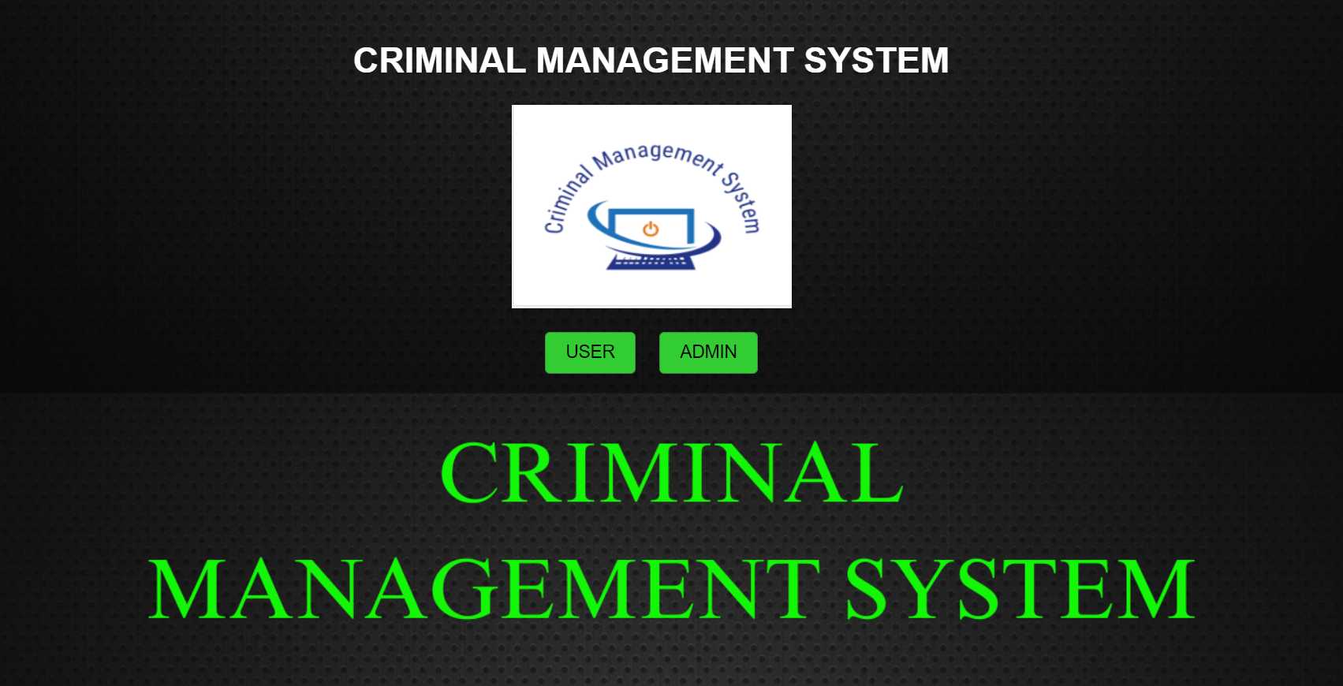

**ADMIN MODULE:-**

1. 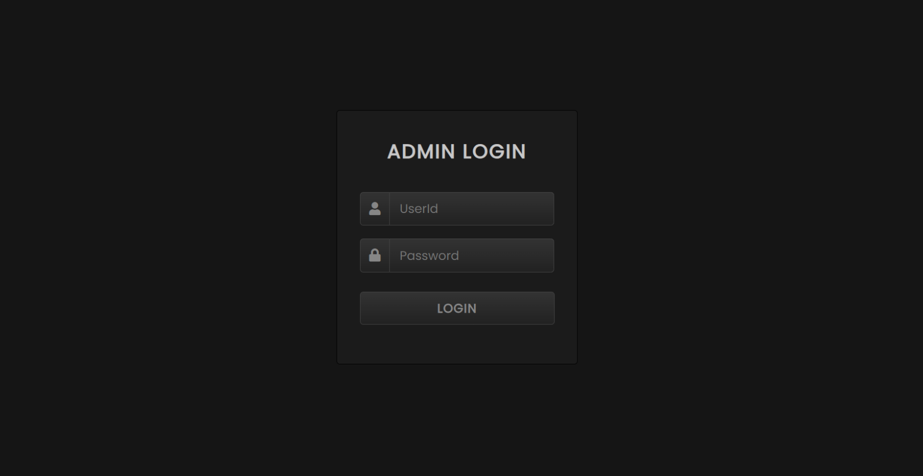**Admin Login:-**
2. **Admin Home:-**
3. 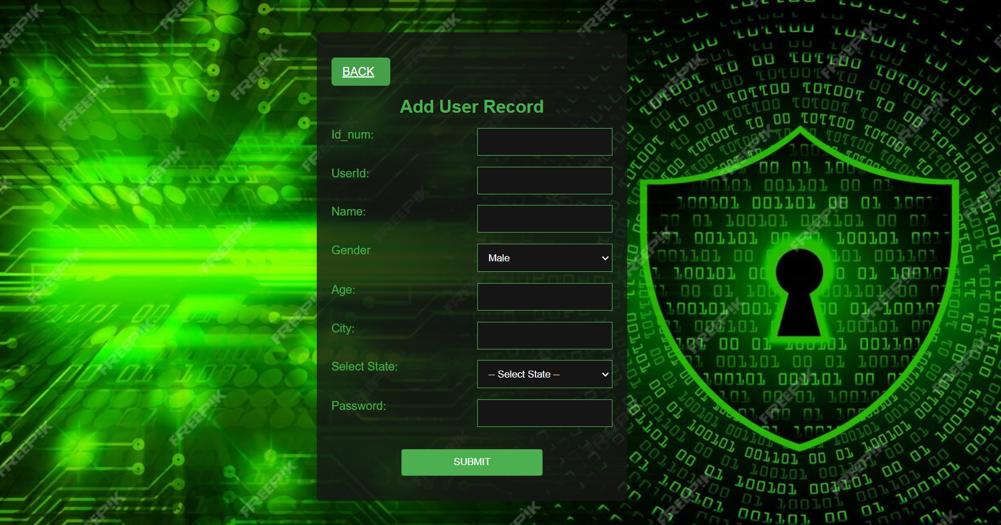**Add User:-**
4. 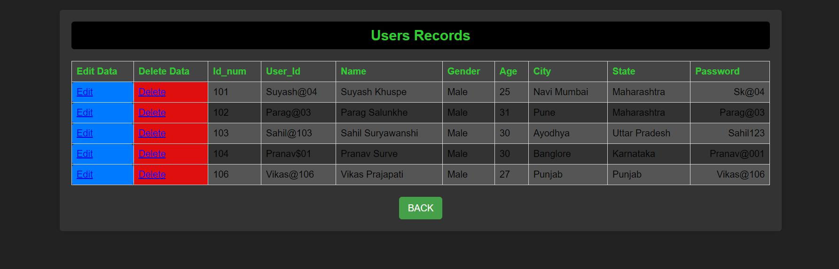**View Added Records:-**
5. 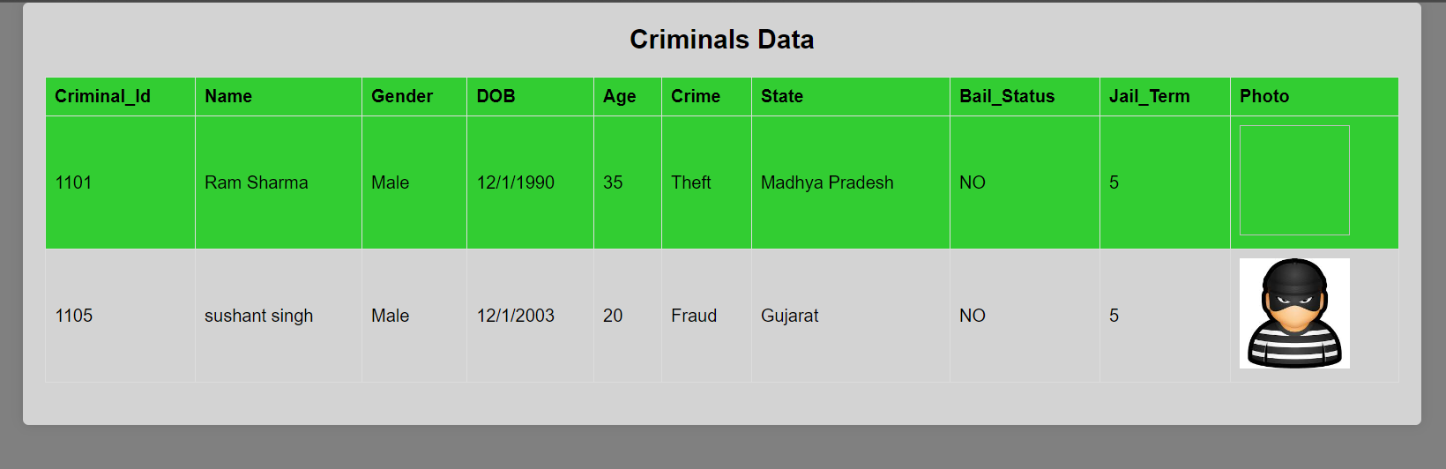**View Criminal Data:-**

**USER MODULE:-**

1. **User Login:-**

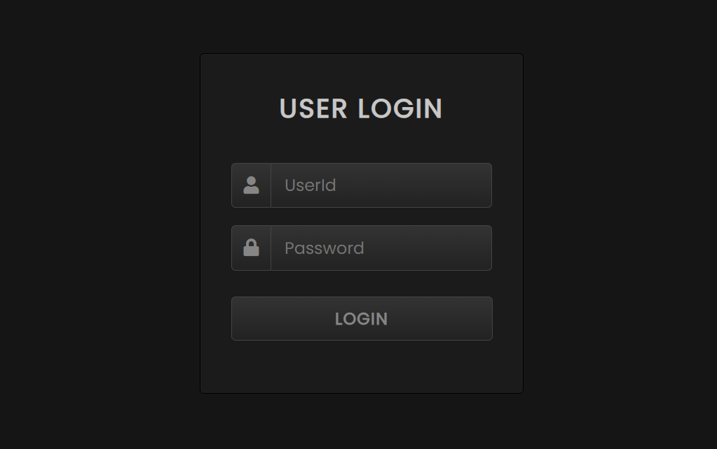

1. **User Home:-**

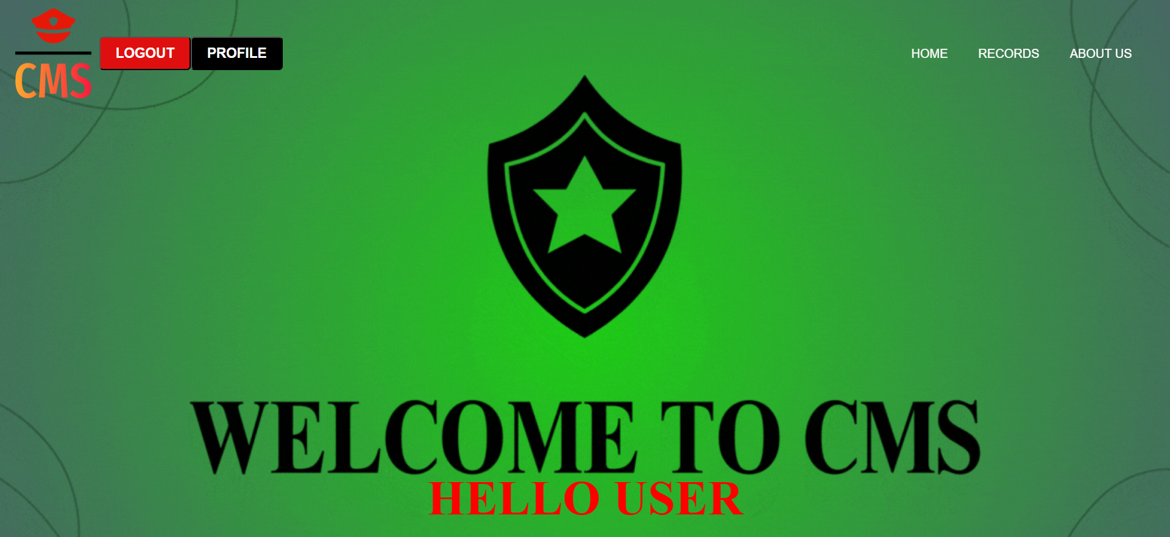

1. **Add Criminal Record:-**

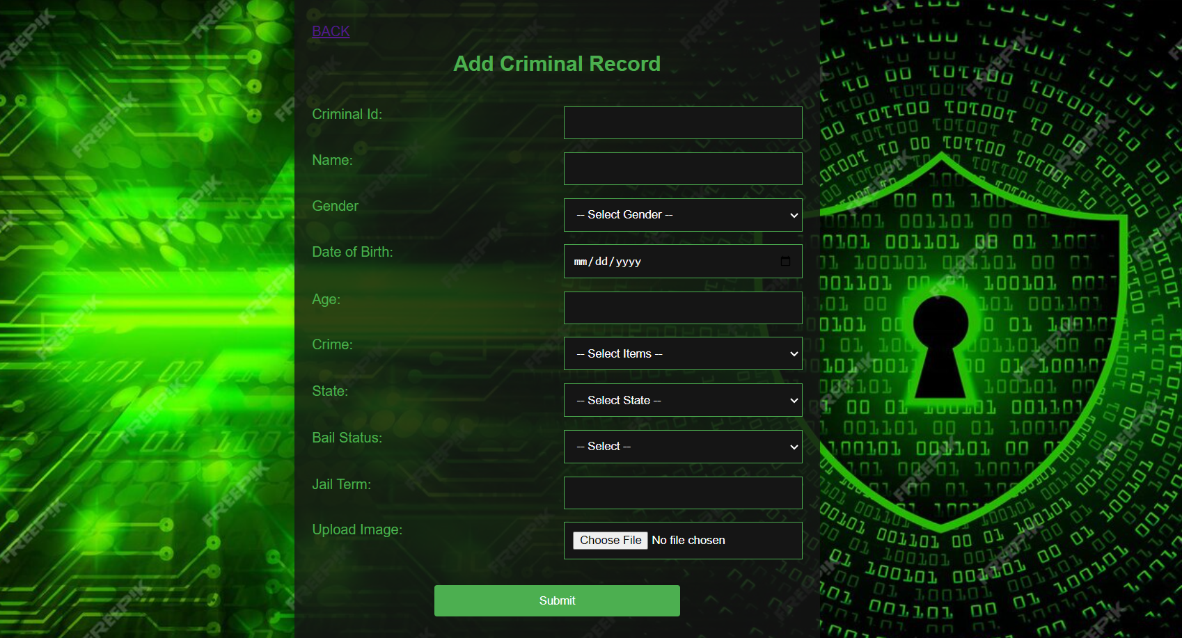

1. **View Records:-**

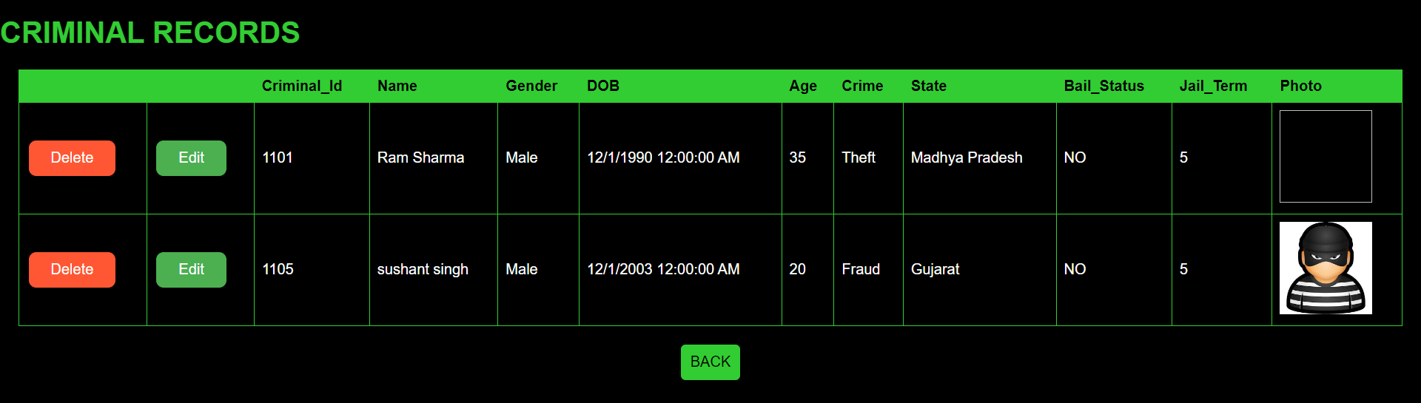

1. **About us:-**

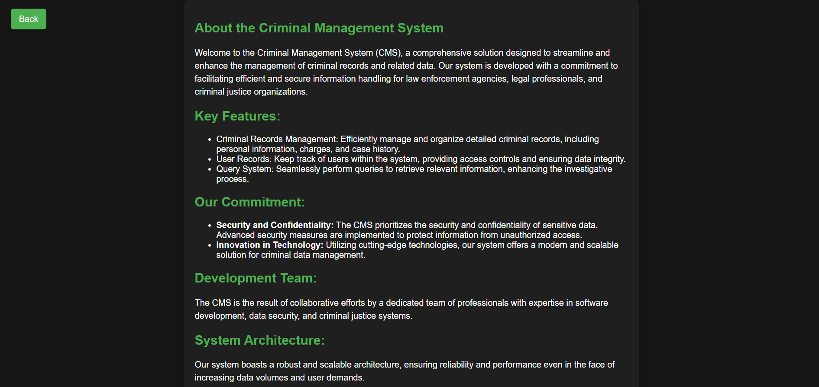

1. **User Profile:-**

